

|  |
| --- |
| Lu Chunqiu, Juri & Marek |
| RTU of RIP |
| Operation and configuration instructions  Technical description |
|  |

|  |
| --- |
| Information Technology |
| 2013 |

**CONTENTS**

1 General 5

2 operation of the RTU **错误!未定义书签。**

2.1 RTU configuration **错误!未定义书签。**

2.1.1 Hardware connecting configuration **错误!未定义书签。**

2.1.2 Embedded software configuration **错误!未定义书签。**

2.2 Operation after start 7

# General

This first part (Operation and configuration) of this manual contains general descriptions of the functions and operation instructions. Also, it contains instructions for configuration of the RTU.

**RTU features**

This RTU can convert the IEC-60870-101(hereafter referred to as IEC101) frame from controlling station to Modbus RTU (hereafter referred to as Modbus) frame and convert the returning Modbus frame back to IEC101 frame. It is developed on Atmel NGW100 development board. It has an AVR32 Linux running on it and embedded RTU software running on Qt 4.6.3 which is compiled on that board. The following table shows the features of this RTU.

|  |  |
| --- | --- |
| **Name** | **Description** |
| NGW100 | Development board |
| Two serial port | RS232-D9 |
| Power supply port | Direct 15V |
| Ethernet port |  |
| AVR32 Linux | RTOS |
| Qt4.6.3 |  |
| Embedded RTU software | For more details, refer to software RTU manual |

Table 1. RTU features

# operation of the RTU

## RTU configuration

To run the RTU, hardware connecting and software configuration should be done. Table 2 shows the essential equipment.

|  |  |
| --- | --- |
| **Name** | **Description** |
| PC | With Putty installed and an Ethernet port |
| Cross-over Ethernet cable |  |
| Two RS232 cable |  |
| Direct power supply | With cable |

Table 2. Essential configuration equipment

### Hardware connecting configuration

Connect the 15V direct power supply to the board and connect one PC to the Ethernet port with a cross-over Ethernet cable. Finally, connect the controlling device to the top RS232 interface and controlled device to the bottom RS232 interface with two RS232 cable separately. Figure 1 shows the connecting diagram. Remember that the serial port transmission parameter is **8 bits, even check bit and 1 stop bit.**

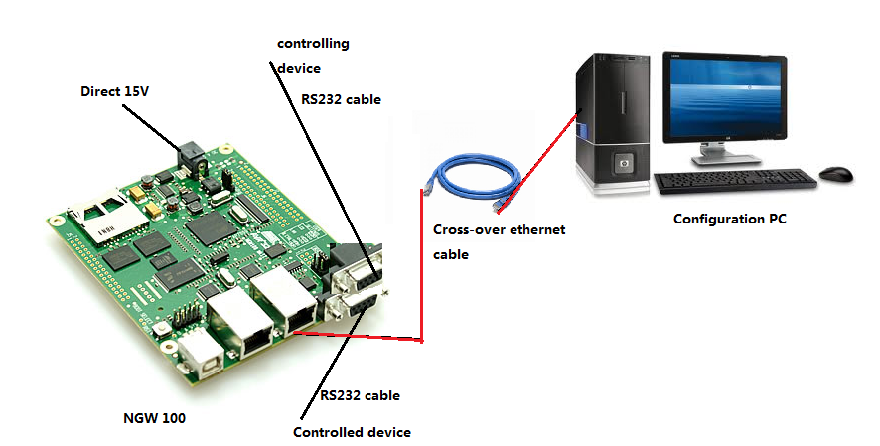

Figure 1. Connecting diagram

### Embedded software configuration

Open the PuTTY and configure as the following figure. The host name is 192.168.69.10 Press open and after a while it will login to the board, shown in the Figure 3. Enter the following account information:

*name: root*

*password: roota*

Change the directory by the command *cd som* and execute the software by *./* *mySerialPortTools_remove_GUI.* Now the embedded RTU is starting.

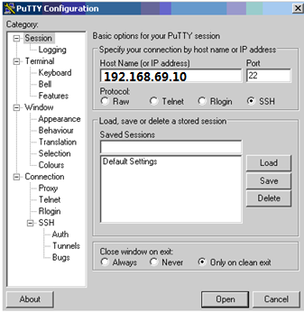

Figure 2. PuTTY configuration diagram

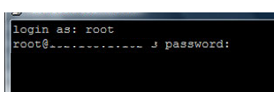

Figure 3. Login in to the board

## Operation after start

In the PuTTY screen, it will show the receiving and send frame in hexadecimal format as well as the corresponding port name in the right receive data part.

To close the program, enter *ctrl+C* to stop.

Content

1 SOFTWARE Environment establish 10

1.1 Essential equipment 10

1.2 Environment configuration 11

2 HARDWARE Environment establish 10

2.1 Essential equipment 10

2.2 Environment configuration 11

3 Possible problem and solution 12

# 1 SOFTWARE ENVIRONMENT ESTABLISH

This part of the user manual describes more technical detail of the RTU. It contains the environment establish process and possible problem.

This chapter aims to describe the software environment establish process on the NGW 100 development board, including the Linux installation, Qt compiling and others.

## 1.1 Essential equipment

Written by Marek, but not available now.

## 1.2 Environment configuration

Written by Marek, but not available now.

# 2 HARDWARE ENVIRONMENT ESTABLISH

This chapter aims to describe the converter making process. This converter converts the TTL USART +5V signal level of the NGW 100 microprocessor to RS232 interface +-12V. Figure 4 demonstrates the overall connecting diagram. The red block is the converter that this chapter describes.

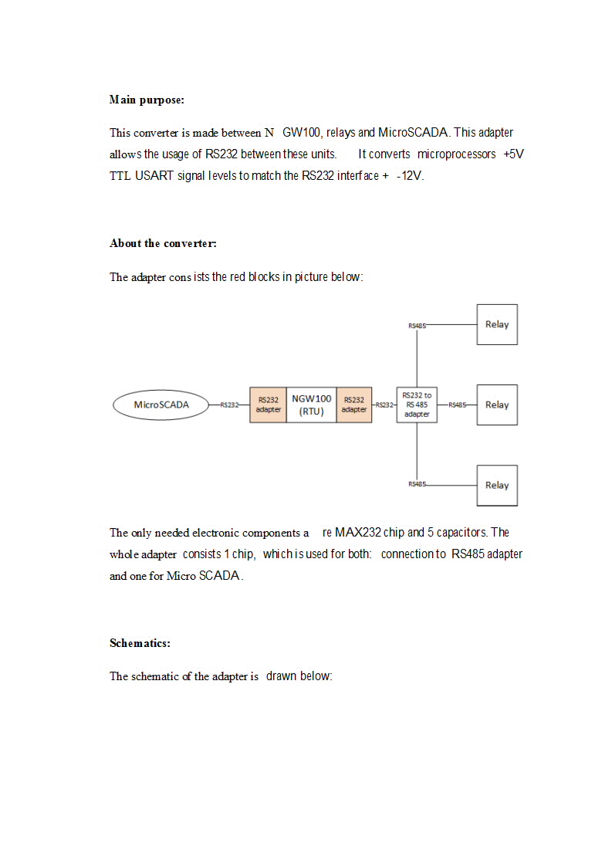

Figure 4. Overall connecting diagram

## 2.1 Essential equipment

|  |  |
| --- | --- |
| **Name** | **Description** |
| NGW 100 |  |
| Two RS232 Female interface | D9 |
| Some cables |  |
| MAX232 chip |  |
| 5 capacitors |  |

## 2.2 Environment configuration

The following is the connecting schematic of the adapter.

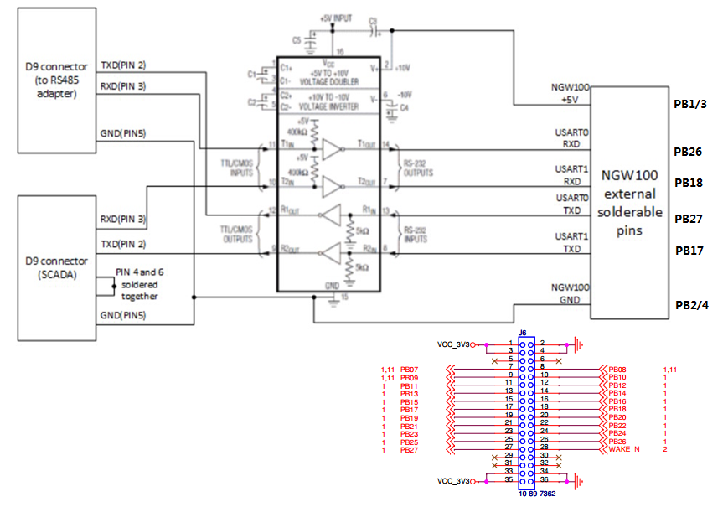

Figure 5. Schematic of the adapter

# POSSIBLE PROBLEM AND SOLUTION

|  |  |  |
| --- | --- | --- |
| **Problem** | **Possible reason** | **Possible solution** |
| Nothing receive | Check if the port name is chosen right. | Refer to software RTU technical manual 6. |
| Check if the RTU starts | Start the RTU |
| Check if the serial transmission parameter is correct. The RTU serial transmission port is 8E1. | Keep the RTU and connecting device parameter the same |
| Frame process accidently stops | Check if the configuration of corresponding relay is right. | Configure the relay so that both the transmission parameter is the same |
| Check if the map address of the receiving frame is right | Refer to software RTU technical manual 6. |
| Other problem | RTU bug | Restart the RTU |